DESC Information Security Regulation Compliance for Log360
Tagline: Support Dubai DESC security compliance with real-time monitoring from Log360.

Overview
The DESC Information Security Regulation Compliance extension for Log360 helps Dubai government entities and organizations operating under Dubai Electronic Security Center oversight meet DESC's information security requirements for access control, incident management, and audit logging.
Log360 collects and analyzes logs from IT systems, network devices, cloud environments, and identity platforms, providing security teams with continuous visibility into critical security events. Compliance teams can track control effectiveness, investigate incidents, and generate the reports required for DESC assessments and government security audits.

Key Features
- Generate predefined audit reports covering DESC information security requirements including user access monitoring, system change tracking, and incident detection.
- Monitor Active Directory, cloud platforms, and network infrastructure for unauthorized access, policy violations, and privilege escalation events.
- Configure threshold-based alerts for DESC-critical security events such as failed login attempts, unauthorized administrative actions, and data exfiltration indicators.
- Export compliance documentation in PDF and CSV formats for DESC regulatory audits and Dubai government security assessments.
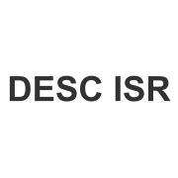


Screenshots
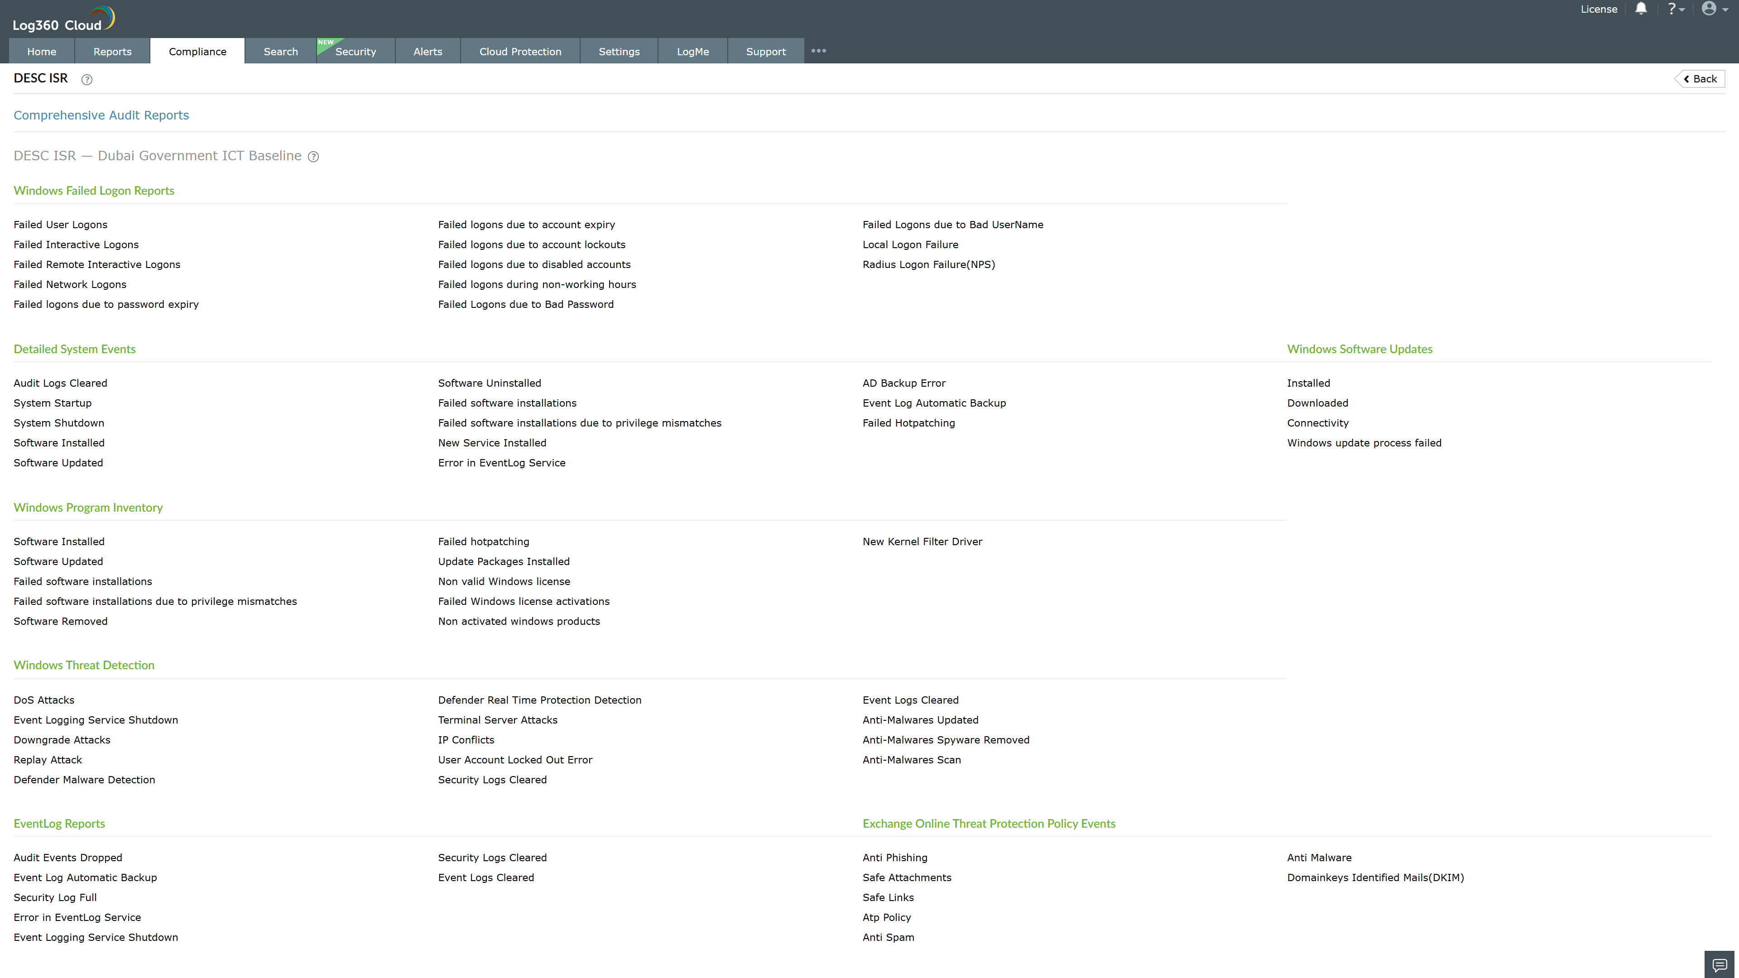
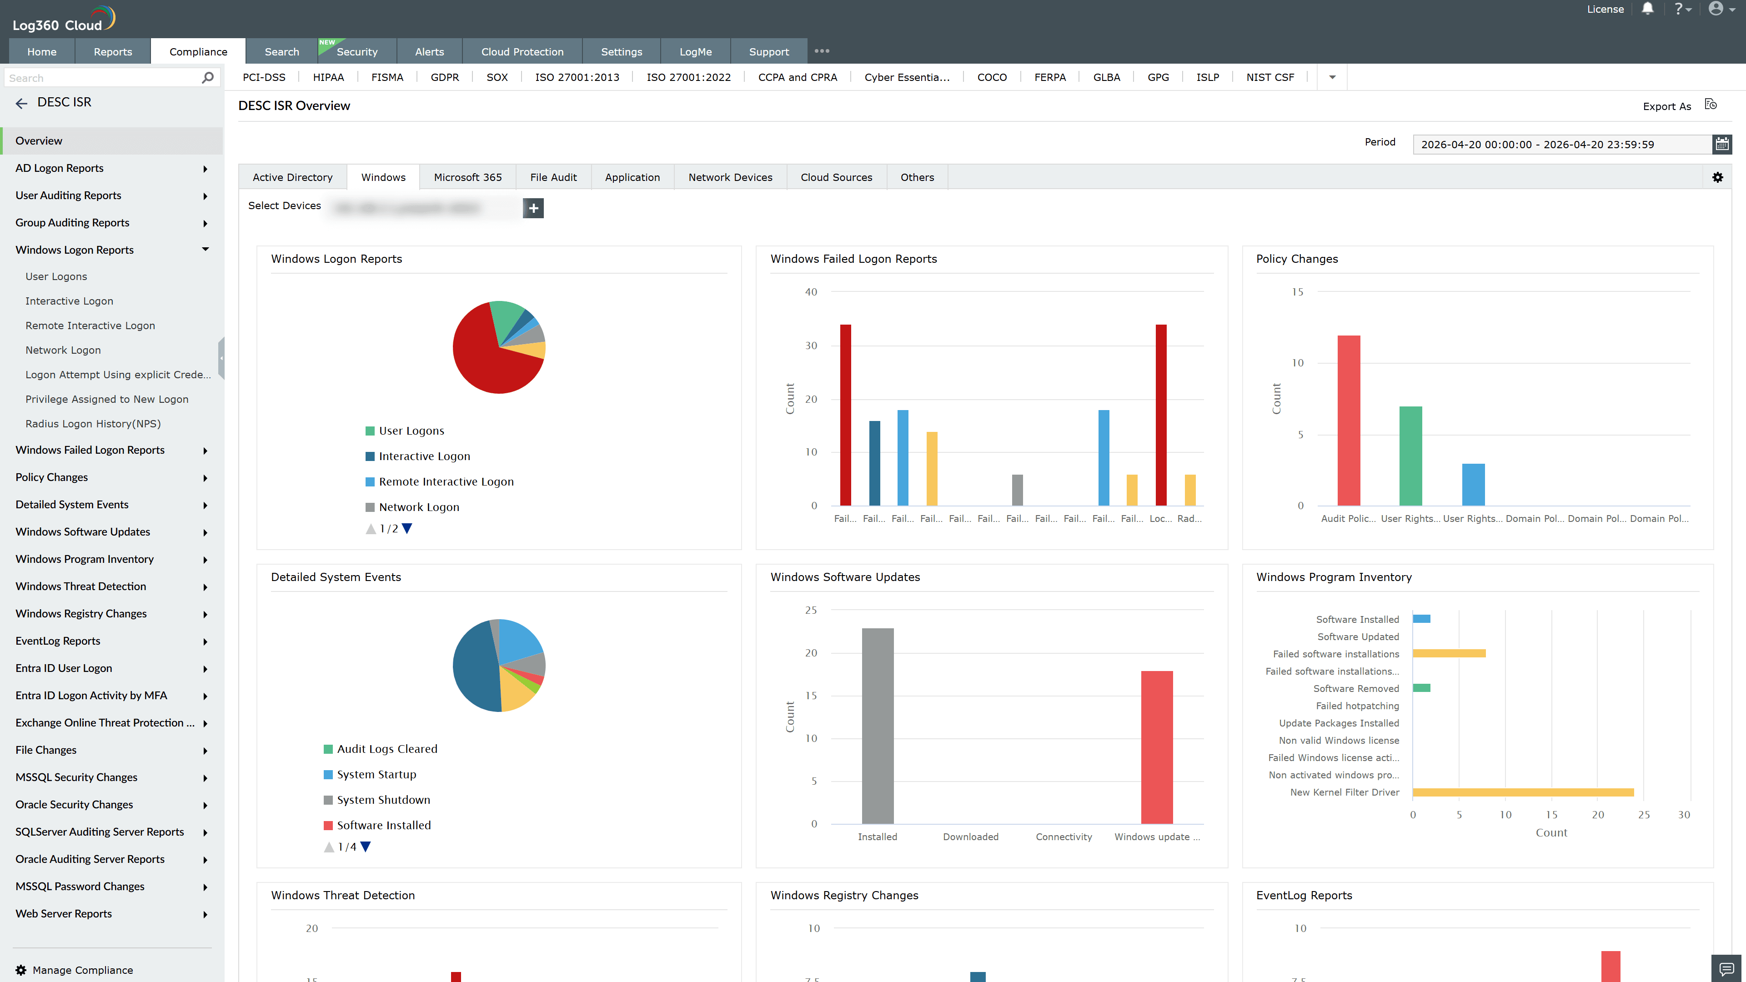
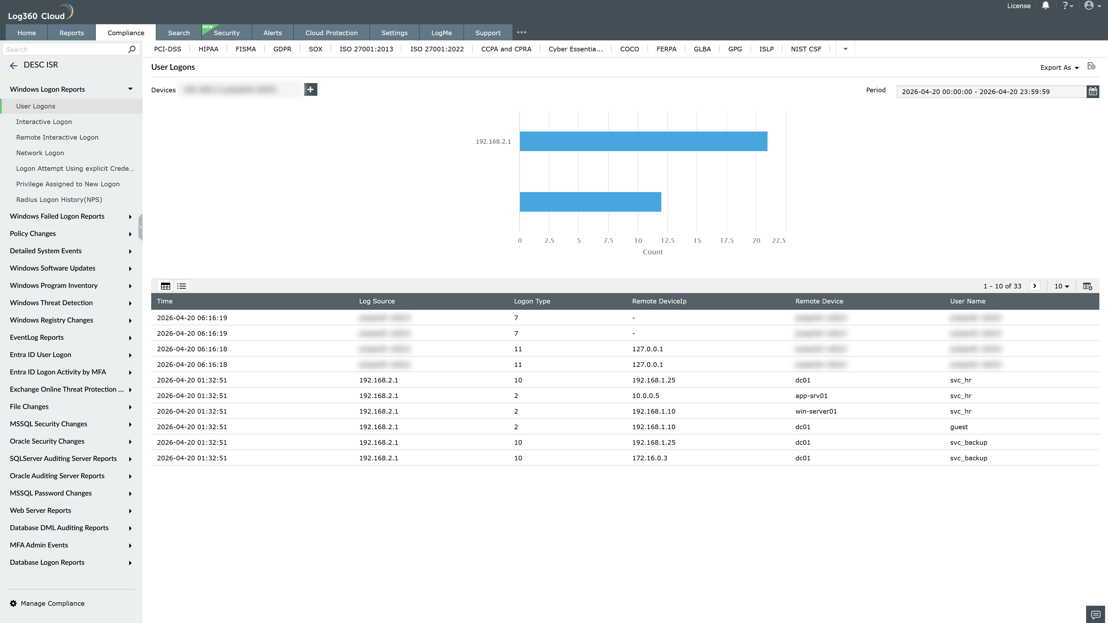
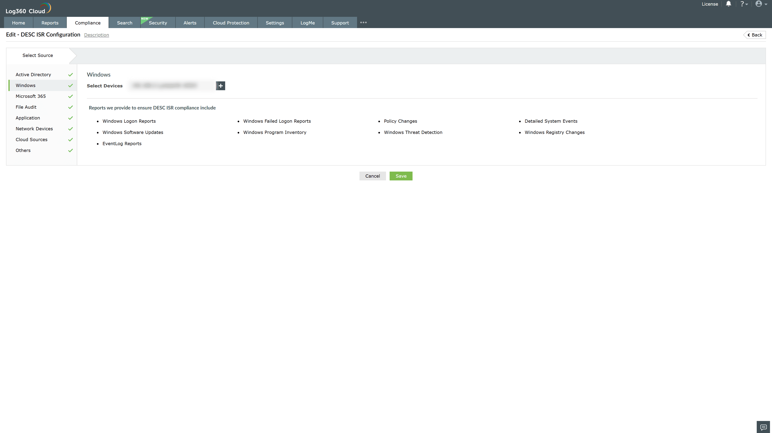
Valid Submission : Yes
Supported Editions : Free, Basic, Standard, Professional, MSSP
Help Document : https://www.manageengine.com/log-management/help/integrations/compliance-extensions.html
Help Video : Not provided
Tags : Log360, Compliance, Privacy monitoring, Data privacy, Regulatory compliance
Supported DCs : US, IN, JP, CA, AU, UK and EU
Privacy Policy:
Terms of Service:
Release Notes:
Predefined reports for the DESC Information Security Regulation Compliance

